 | 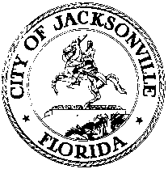
 | OFFICE OF THE CITY COUNCIL
ANNA LOPEZ BROSCHE  PRESIDENT  JACKSONVILLE CITY COUNCIL  OFFICE (904) 630-1452 |  | SUITE 425, CITY HALL  117 WEST DUVAL STREET  JACKSONVILLE, FLORIDA  32202
TASK FORCE ON OPEN GOVERNMENT
AGENDA
June 6, 2018
Lynwood Roberts Room
1:00 pm

Introductions

Jacksonville Sheriff’s Office
Agnes J. Carswell, Public Records Manager and Amanda Carter, Public Records Coordinator

Survey Results
The Task Force on Open Government Access to Government Survey Results

Discussion

Public Comment

Chairs: Hank Coxe and Dr. Sherry Magill
Members: Ywana Allen
Rachael Fortune
The Honorable Alberta Hipps
Ron Littlepage
Michael Lockamy
Audrey Moran
The Honorable Jim Overton
Sabeen Perwaiz
Cleve Warren-EXCUSED

The next Task Force Meeting will be Tuesday, June 12, 2018 1:00 pm in Committee Room B
117 West Duval Street, 1st Floor

